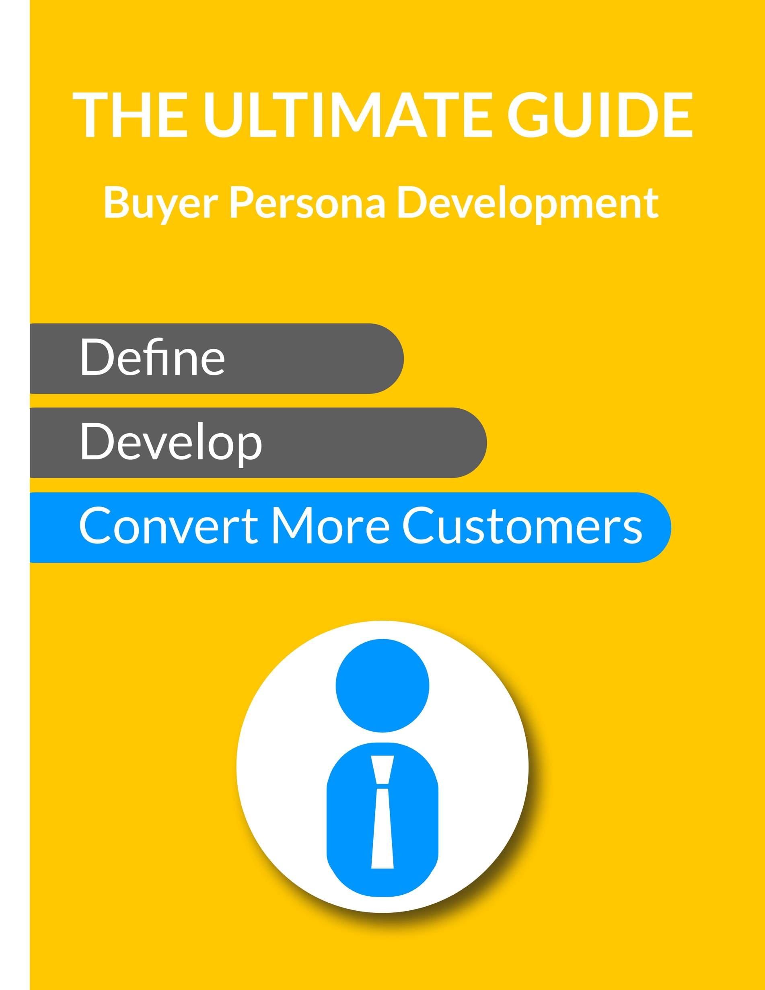

Insert a picture of someone who looks like this buyer persona. | Your Buyer Persona Name:  One Sentence Description of their Problem or Challenge:
Persona Detail | Questions to Ask | TAILORED Questions to Ask (Specific Vertical)
Tailor the questions in Column 2 and 3 for your Buyer Persona and Industry
The word “your” refers to the Buyer Persona himself. Add additional questions as they apply to your Buyer Personas.
Name Your Buyer Persona: Replace references to “Person” with your Buyer Persona’s Name
This template is developed for a B2B business. B2C businesses should refine the questions accordingly.
Role | What is your job role/role in life?  Your title?  What is a typical day?  Is this person a decision maker? | Job Role:  Job Measured & Typical Day:  Skills Required:  Business Size:  Education:  Years in Business:  Decision Maker:  Personal Quote:
Annual Corporate Revenue | Last Year Revenue:  This Year Revenue Goal:  Next Year Growth / Rev Goal:
Psychographic | Annual Business Planning?  Formal Strategic Plan?  Growth minded?
Achievements | What does it mean to be successful in your role?
Responsibilities | What responsibilities does your buyer persona have? | At Work:  At Home:
What are this Persona’s 12 – 18 month goals? | What does it mean to be successful in your role?
Challenges | What are your biggest challenges?
What are his pain points? | What types of concerns, challenges, obstacles does he face as a result of his business goals and objectives?
When he fails at his performance goals and objectives, who else feels the pain? | What are the consequences to his upper level managers when he doesn’t succeed?
Watering Holes | What publications or blogs do you read?  What associations and social networks do you belong to?  What content does he/she gravitate toward
Online Interests | What type of online user category best describes them (See Interests in Google Analytics)?
Resources I trust
Personal Background | Age, Family (married, children),
Shopping Preferences | Do you use the internet to research vendors or products? If yes, how do you search for information?
What does this Persona’s typical day look like?
Priority Initiative | What business conditions trigger this buyer’s decision to look for your solution?
What does your solution help him solve?
What does this Personal value most?
Where does this Persona go for information?
Success Factors | What results or outcomes does this buyer persona expect from your solution?
Perceived Barrier | What attitudes or concerns prevent this buyer from investing in your solution or why wouldn’t they purchase it from you?
Decision Criteria | What elements of your solution does this buyer evaluate as they compare alternative approaches or other providers in the decision making process?
Buyer’s Journey | What is this buyer’s role in the decision and who else will impact the decision? What resources will they trust to guide the decision?
What experience is he looking for when seeking your services, products or solution?
What are his most common objections to your solution… to the providers / vendors of the solution?
Post Purchase – What challenges does this persona encounter when implementing your solution? | Identify and develop resources you can provide to resolve these issues or prevent them from occurring?
Post Purchase –  What obstacles might your buyer encounter while using your solution? | Identify and develop resources to help your buyer prevent the obstacles before they occur or help them resolve them quickly?
Post Purchase –  What opportunities are created when your customer is successful using your solution? | Develop content that will help your customer achieve or create the opportunities. Show them how to maximize success as they navigate them.
Post Purchase –  What competitive advantages does your product create for your client? | Identify the competitive advantages your solution can create for your customer. Create content that helps your customer understand the opportunities and give them step-by-step support in leveraging your solution to create competitive advantage.
Loves Your Company Because

Add to your buyer persona template to create the most palpable customer persona description possible. The more you know about how he or she thinks, what they need, where they show up, what they want, what they are afraid of, their goals, aspirations, challenges and resources, the better your content will be.

Need help? Call us. It’s free!

